1.

2.

3.

4.

5.
6.
7.

8.

9.
10.
11. Men’s shirt sizes are determined by their neck sizes. Suppose that men’s neck sizes are approximately normally distributed with mean 15.7 inches and standard deviation 0.7 inch. A retailer sells men’s shirts in sizes S, M, L, XL where the shirt sizes are defined in the table below.
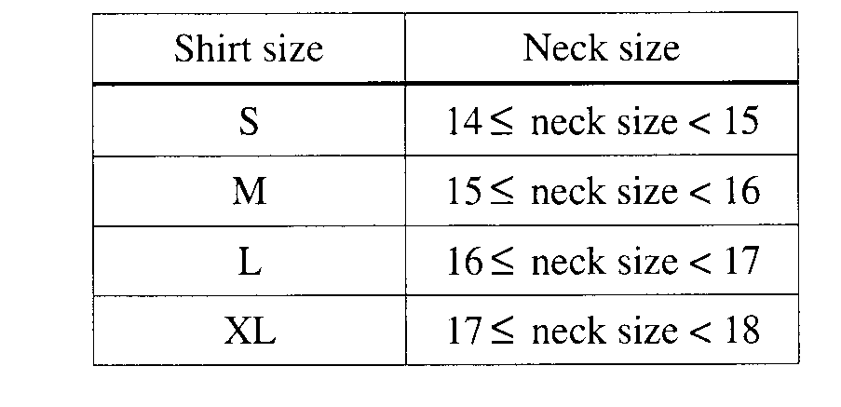
(a) Because the retailer only stocks the sizes listed above, what proportion of customers will find that the retailer does not carry any shirts in their sizes? Show your work.

(b) Using a sketch of the normal curve, illustrate the proportion of men whose shirt size is M. Calculate this proportion.

(c) Of 12 randomly selected customers, what is the probability that exactly 4 will request size M ? Show your work.

12. Scores of students on a test are approximately normally distributed with a mean score of 70 points and a standard deviation of 10 points. It is decided to give A’s to 10 percent of the students and B’s to 23 percent of the students. What scores should be assigned to A’s and B’s?

13. The demand for meat at a grocery store during any week is approximately normally distributed with a mean demand of 5000 pounds and a standard deviation of 300 pounds.
a. If the store has 5300 pounds of meat, what is the probability that it is overstocked?

b.How much meat should the store have in stock per week so as not to run short more than 10 percent of the time?

